#### **Weaving Color**

**Grades 3 and up**

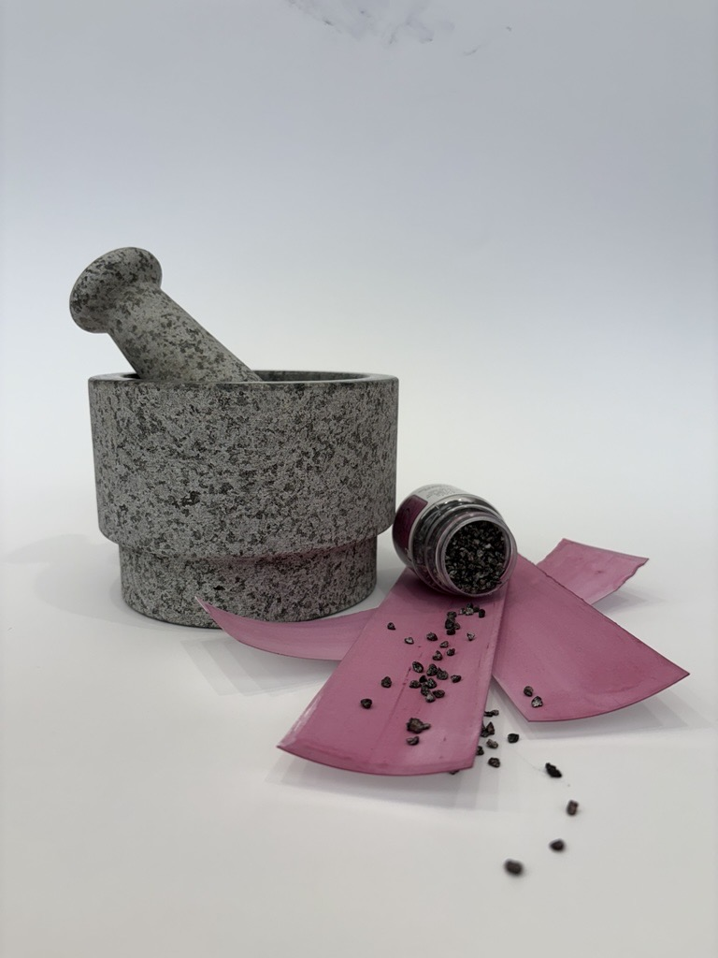

Link to image:[Image (8).jpg](https://nelsonatkins.sharepoint.com/:i:/s/StudioExperiences/ERJP29WPcGpHu5zFCjXAubMBZcPM3h-ah73M6L4VSk26cQ?e=H1idMQ)

**Workshop Overview**

**Experience the ingenuity of Indigenous artists from Mexico and Central America in** [***Painted Worlds: Color and Culture in Mesoamerican Art.***](https://nelson-atkins.org/art/exhibitions/painted-worlds-color-and-culture-in-mesoamerican-art/) **Explore the significance of color and the creation of natural pigments spanning 3,000 years of artistic practice. Then weave this newfound knowledge into an original artwork to take home. During the Dia de los Muertos altar display (Nov. 3 - Nov. 10, 2025), participants will visit both the exhibition and the altar designed by** [**Porfirio Gutierrez**](https://www.porfiriogutierrez.com/)**, a contemporary artist featured in *Painted Worlds*.**

**Outcomes**

* Identify various types of artwork as primary sources from which to learn about Mesoamerican culture.
* Discuss objects created by weaving; develop greater appreciation for artworks after trying the weaving process.
* Utilize colors that feature heavily in Mesoamerican art in a design that conveys personal meaning.

**Curriculum Questions**

* How does art help us to understand the lives of people of different times, places and cultures?
* How does learning about art change the way we view the world around us?
* Why do artists follow or break from established traditions?

**Vocabulary/Concepts**

|  |  |  |
| --- | --- | --- |
| Mesoamerica – a region comprising what is now Mexico and Central America | Warp – threads held under tension on a loom | Weft – threads interlaced with the warp to create fabric |
| Weaving – the craft of forming fabric by interlacing threads. | Natural Pigments – coloring substance derived from plants, minerals or animals (not synthesized in a lab) | Cochineal – scale insect native to Mexico used to create red dye |

**Pre-Workshop Activities**

* Watch this video for background information about the *Painted Worlds* exhibition: [Harvesting Color: Ancestral Recipes for Today’s World](https://www.youtube.com/watch?v=HpS_zgcaE98)
* The Florentine Codex documented the impressive knowledge of indigenous people in Mesoamerica that existed long before other people arrived there. Scholars have translated it into Spanish and English and have also digitized the content. You can explore the Digital Florentine Codex at this link: [Digital Florentine Codex](https://florentinecodex.getty.edu/)
  + Do the drawings of animals look like ones you have seen before? Why or why not? Are there animals you are surprised to see or not see? Why?
  + How does the list of occupations compare to the jobs of adults you know? Which job would you choose?
  + Create a mini-codex describing important parts of your life. If you could give information about living in 2025-2026 to someone many years from now, what would you want them to know?
* Learn more about Mesoamerica with National Geographic: [Mesoamerica](https://education.nationalgeographic.org/resource/resource-library-mesoamerica/)

**Post-Workshop Activities**

* Write an artist’s statement about the weaving you created. What colors did you choose? What do they mean to you? Was weaving easy or challenging?
* Continue weaving with your loom! Here is a video to help; it includes instructions for tying off the loom for reuse: <https://www.youtube.com/watch?v=AWLIy-Um7_0>
* Research ways to create natural dyes from plants in your area. Here is a link to get you started: <https://www.fs.usda.gov/wildflowers/ethnobotany/dyes.shtml>